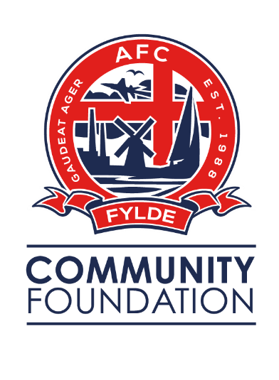

Job Description

Job Title: Community Partnerships Officer

Territory Area: Fylde

Hours: 40 hours per week – flexible including evenings and weekends

Salary: £19,000 - £23,000 per annum (dependant on experience)

Length of Contract: Initial 12 month fixed term

Location: Mill Farm Sports Village, Coronation Way,
Wesham, PR4 3JZ

Role Summary:

AFC Fylde Community Foundation is looking to recruit a Community Partnerships Officer to work closely with new and existing community stakeholders to identify and develop new projects, securing additional funding to ensure financial sustainability.

This is a new and exciting position at the Foundation with the potential for growth for the successful candidate. A key part of the role will be generating income that we can utilise to sustain and grow the services the Foundation offers, ultimately improving the lives of people across the Fylde Borough.

The nature of this role will require the successful candidate to be a strong communicator, enthusiastic, confident, inspirational and capable of creating excellent working relationships. The role will also demand an ambitious, strong willed and influential individual to hit the ground running and achieve the key performance indictors set out from the start.

Guidance and Authority:

The Community Partnerships Officer will report directly into the Assistant Foundation Director.

Main Duties:

- Increase income into our charitable work through developing effective relationships with private sector partners, patrons, sponsorships, CSR, fundraising and events.
- Represent the Foundation on local partnership groups with a view to building mutually beneficial partnerships to support our sustainability.
- Identify opportunities for community initiatives and oversee planning and implementation.
- Prepare and submit successful pitches to potential partners and conduct effective negotiations.
- In consultation with staff and partners, support the Foundation Director in the development and implementation of a Foundation Fundraising Strategy.
- Recruit, train, support, develop and manage volunteers who support with fundraising activities.
- Work closely with AFC Fylde’s Commercial Department on developing Club and Charity joint income initiatives.
- Evaluate and monitor activities and projects using performance indicators, including income and surplus indicators and targets.
- Maintain records and produce written reports, demonstrating how the post is contributing to the sustainability of the organisation.
- Develop a range of partnerships with organisations and initiatives.
- Collect the required monitoring information and ensure it is recorded accurately on the VIEWS on-line monitoring and evaluation system.
- Ensure all activities are correctly monitored with the appropriate risk assessments and health and safety procedures put in place.
- Be a flexible member of the AFC Fylde Community Foundation team and when requested assist in the delivery of other projects and activities including evenings and weekends.

Health and Safety:

- Fully endorse, demonstrate, and carry out the Foundation’s health and safety policy.
- Comply with all group policies and statutory regulations relating to health and safety, safe working practices, hygiene, cleanliness, fire and COSHH. This will include your awareness of any specific hazards in your workplace and assist if required with the amending of risk assessments periodically.
- Have a full knowledge of procedures for evacuation with regards to fire safety.
- Identify and report maintenance requirements or hazards within the workplace and encourage any workforce to do the same to avoid injury.

Safeguarding:

- The Foundation is committed to safeguarding the welfare of children and young people and expects all staff and volunteers to endorse this commitment.
- The employee must act to protect all young people and vulnerable adults that are in their care or attending the group’s premises. The employee must report any misconduct or suspected misconduct to the Foundation Director.

General:

- Cooperate fully with colleagues and be flexible when assisting them in response to business needs of the Foundation.
- Ensure a positive commitment towards equality and diversity by treating others fairly and not committing any form of direct or indirect discrimination, victimisation, or harassment of any description and to promote positive working relations amongst employees and customers.
- The above job description is not intended to be exhaustive; the duties and responsibilities may therefore vary over time according to the changing needs of the group.

Person Specification

 | Essential Requirements | Desirable Requirements
Qualifications & Experience | - Commercially astute with a proven experience of increasing income via corporate fundraising and partnership working.  - Demonstrable experience of developing and maintaining working relationships with senior figures / stakeholders in other organisations. | - Educated to degree standard (or equivalent) in sport or business related subject.
Knowledge & Skills | - An understanding of Charity Law and Fundraising regulations.  - An understanding of and a commitment to equal opportunities issues both in the workplace and the wider community.  - Excellent communication skills both written and verbal.  - Ability to organise and prioritise work to meet deadlines.  - Ability to travel to different sites. | - A good knowledge of key organisations in Fylde, including NHS, local authorities, voluntary groups and organisations.
Personal Qualities | - Passionate about liaising with people and proactive about building new and existing relationships  - Positive attitude with the ability to motivate and enthuse individuals and groups.  - Self-motivated with the ability to prioritise own work  - Ability to work well in own and as part of a team  - Confident and articulate  - Ability to perform under pressure and respond calmly to competing demands  - Strong communicator  - Enthusiastic  - Inspirational  - Ambitious  - Strong willed  - Influential

Job Review

The job description will be reviewed periodically to take into account changes and developments in service requirements. Any changes will be discussed fully with the post holder.

Signature of Post holder: ………………………..…… Date: …………………

Signature of Manager: ………………………………… Date: ……………….…

